**Software Engineering Assignment**

* **What is software? What is software engineering?**
* Software is a set of instructions, data or programs used to operate computers and execute specific tasks. Software is a generic term used to refer to applications, scripts and programs that run on a device.
* Software engineering is the process of designing, developing, testing, and maintaining software. It is a systematic and disciplined approach to software development that aims to create high-quality, reliable, and maintainable software. Software engineering includes a variety of techniques, tools, and methodologies, including requirements analysis, design, testing, and maintenance.
* **Explain types of software ?**
* There are five type of software.
* Application software**:-** The most common type of software, application software is a computer software package that performs a specific function for a user, or in some cases, for another application. - An application can be self-contained, or it can be a group of programs that run the application for the user. - Examples of Modern Applications include office suites, graphics software, databases and database management programs, web browsers, word processors, software development tools, image editors and communication platforms.

-Example:-Microsoft Office, Paint, Powerpoint etc..

* System software**:-** These software programs are designed to run a computer's application programs and hardware. - - System software coordinates the activities and functions of the hardware and software. - It controls the operations of the computer hardware and provides an environment or platform for all the other types of software to work in. - The OS is the best example of system software; it manages all the other computer programs. - Other examples of system software include the firmware, computer language translators and system utilities..

**-** Example:-Notepad ,Calculator etc..

* Driver software:**-** Also known as device drivers, this software is often considered a type of system software. - Device drivers control the devices and peripherals connected to a computer, enabling them to perform their specific tasks. - Every device that is connected to a computer needs at least one device driver to function. - Examples include software that comes with any nonstandard hardware, including special game controllers, as well as the software that enables standard hardware, such as USB storage devices, keyboards, headphones and printers.

-Example:-Audio Driver,Video Driver etc..

* Middleware**:-** The term middleware describes software that mediates between application and system software or between two different kinds of application software. For example, middleware enables Microsoft Windows to talk to Excel and Word. - It is also used to send a remote work request from an application in a computer that has one kind of OS, to an application in a computer with a different OS. It also enables newer applications to work with legacy ones.

- Example: database middleware,application server middleware.

* Programming software:- Computer programmers use programming software to write code. Programming software and programming tools enable developers to develop, write, test and debug other software programs. - Examples of programming software include assemblers, compilers, debuggers and interpreters.

- Examples : Turbo c,Eclipse,Sublime etc..

* **What is SDLC? Explain each phase of SDLC.**
* The Software Development Life Cycle (SDLC) is a process used by software development organizations to plan, design, develop, test, deploy, and maintain software applications.
* The Software Development Life Cycle (SDLC) refers to a methodology with clearly defined processes for creating high-quality software. in detail, the SDLC methodology focuses on the following phases of software development:

1. Requirement Gathering

2. Analysis

3. Designing

4. Implementation

5. Testing

6. Maintenance

1. Requirements gathering and analysis:- This phase involves gathering information about the software requirements from stakeholders, such as customers, end-users, and business analysts.

2. Design:- In this phase, the software design is created, which includes the overall architecture of the software, data structures, and interfaces. It has two steps:

•High-level design (HLD):- It gives the architecture of software products.

•Low-level design (LLD):- It describes how each and every feature in the product should work and every component.

3. Implementation or coding:- The design is then implemented in code, usually in several iterations, and this phase is also called as Development.

things you need to know about this phase:

•This is the longest phase in SDLC model.

•This phase consists of Front end + Middleware + Back-end.

•In front-end: Development of coding is done even SEO settings are done.

•In Middleware: They connect both the front end and back end.

•In the back-end: A database is created.

4. Testing:- The software is thoroughly tested to ensure that it meets the requirements and works correctly.

5. Deployment:- After successful testing, The software is deployed to a production environment and made available to end-users.

6. Maintenance:- This phase includes ongoing support, bug fixes, and updates to the software.

* **What is DFD? Create a DFD diagram on Flipkart.**
* **DFD** is the abbreviation for **Data Flow Diagram**. The flow of data of a system or a process is represented by DFD. It also gives insight into the inputs and outputs of each entity and the process itself.
* DFD does not have control flow and no loops or decision rules are present. Specific operations depending on the type of data can be explained by a flowchart

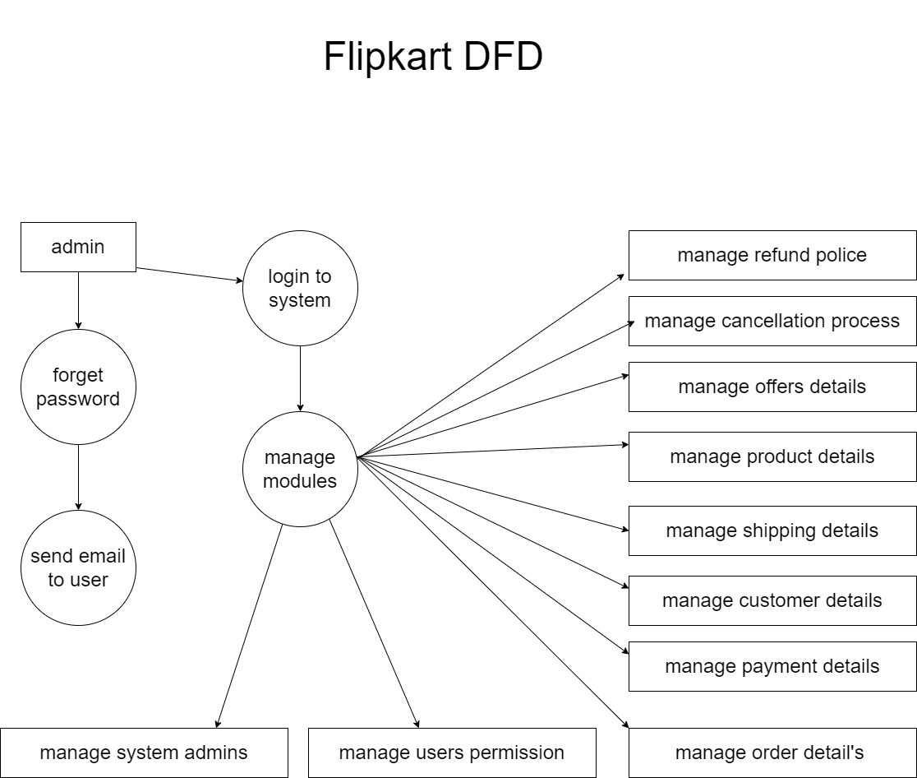

* **What is Flow chart? Create a flowchart to make addition of two numbers?**
* A flowchart is a picture of the separate steps of a process in sequential order.
* It is a generic tool that can be adapted for a wide variety of purposes, and can be used to describe various processes, such as a manufacturing process, an administrative or service process, or a project plan.

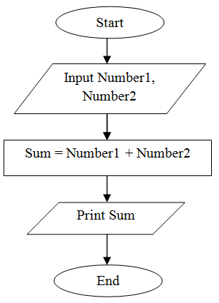

* **What is Use case Diagram? Create a use-case on bill payment on paytm ?**
* In the Unified Modeling Language (UML), a use case diagram can summarize the details of your system's users (also known as actors) and their interactions with the system.
* To build one, you'll use a set of specialized symbols and connectors. An effective use case diagram can help your team discuss and represent.
* The purpose of a use case diagram in UML is to demonstrate the different ways that a user might interact with a system. Create a professional diagram for nearly any use case using our UML diagram tool.

